First name :

Family name :
First name :

Family name :

Practical Session 2 v3.1

Building a Proxmox cluster

Two more proxmox servers
We are going to build a small datacenter using multiple hypervisors. This is going to be useful if we want to use High Availability on the services we provide. When necessary, we will be able to migrate a virtual machine from one hypervisor to another with a very small (ore even without) downtime.
To easily manage multiple hypervisors, Proxmox requires you to configure a “cluster”. You will need multiple computers running Proxmox and make them aware of each other.
You should already have your “proxmox1” computer, you will also need “proxmox2” and “proxmox3”. You have to create them as in the first practical session (disk, ram, iso file, …).
You can use other IP addresses as long as you correctly adjust the various configuration files. In the following assignment, the recommended IP addresses are the following:
Proxmox1 | 192.168.57.11
Proxmox2 | 192.168.57.12
Proxmox3 | 192.168.57.13

Create and start the two new virtual machines. Make sure you can connect to their web interfaces and that they are able to reach the internet. As in the first session, you will need to add port redirection on 706vdi-iot-xxx machine in order to access your new servers.
Lets use the following redirections (on 706vdi-iot-xxx). You need to use iptables as in session 1:

Outside port | Protocol | Local address | Local port
8007 | TCP | 192.168.57.11 | 8006
8008 | TCP | 192.168.57.12 | 8006
8009 | TCP | 192.168.57.13 | 8006

On each of those machines (proxmox1, proxmox2 and proxmox3), you should have an initial “ens18” network interface that allows you to access the internet. You should also have a virtual bridge name “vmbr0”, automatically created during installation and bounded to “ens18” interface.
Those bridges should carry an IP address belonging to the 192.168.57.0/24 network from the list above.

Configuring the data network
We should never use one network interface for everything. We should use multiple interfaces, each dedicated to a task. For now, our servers have only one network interface (blue), that is intended for internet connection. We need to add a second network interface to allow data (VM and files) to flow without competing with user (internet) traffic..
To allow communications through those new interfaces, they need to be connected to each other. For this, we will bind them all to the vmbr2 virtual bridge from 706vdi-iot-xxx. The network topology should be the following:

Adding new network interfaces to the Proxmox servers requires to modify the proxmox1, proxmox2 and proxmox3 virtual machines.
From the 706vdi-iot-xxx interface, you need to go to the hardware properties of the VMs and add a new network device. Be careful to use the “vmbr2” bridge.
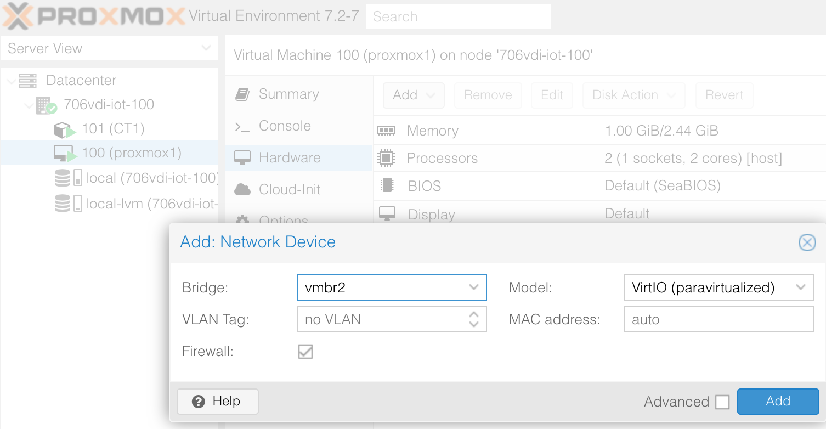
Adding an interface is not enough, it has to be configured. But the network configuration has to be done from inside the proxmox1 to proxmox3 VMs.
So go to the web interfaces of your servers, in the System / Network menu.
You should observe that a new ens19 interface shows in the list. To make this new interface available to virtual machines inside proxmox1, you need to create a virtual bridge.
- name: vmbr1
- address: 192.168.59.11 (proxmox1), 192.168.59.12 (proxmox2), 192.168.59.13 (proxmox3)
- no gateway (this network is only for direct communication between servers)
- bridge port: ens19 (the network interface you just added)

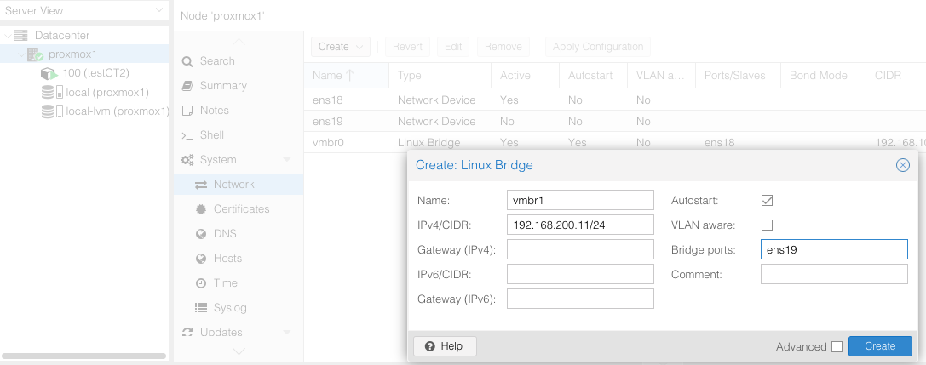
After adding the new bridge, don't forget to apply the configuration with the dedicated button.
To summarize, inside each of your VM should have two network interfaces configured as in the following tables.
Be careful with the host names and the ip addresses. You don’t want multiple server to share an IP address !
name | vrmbr0 (attached to ens18) | vmbr1 (attached to ens19)
proxmox1 | 192.168.100.11 / 24 | 192.168.200.11 / 24
proxmox2 | 192.168.100.12 / 24 | 192.168.200.12 / 24
proxmox3 | 192.168.100.13 / 24 | 192.168.200.13 / 24

The 192.168.200.0 / 24 network will be used to synchronize the proxmox servers with each others, but also to exchange data with the Ceph servers. You have to make sure they know their respective IP addresses and host names.
For this, you have to modify the /etc/hosts files on each virtual machine.
The /etc/hosts files should look like this:
127.0.0.1 localhost.localdomain localhost

# 100 network, for internet access, using the FQDN

# ATTENTION you need to remove the lone "proxmox1" from the followinf line.
# It should now look like this :
192.168.100.11 proxmox1.univ-fcomte.fr

# 200 network, for communications inside the cluster
192.168.200.11 proxmox1
192.168.200.12 proxmox2
192.168.200.13 proxmox3

You have to modify this file on each of your five servers.
Test you configuration by pinging your servers using the host names. Note that the “ping” command can use the auto-completion. You need to press the TAB key two consecutive times and the hostname should be autocompleted (this is a great way to prevent input errors).
On all three servers:
Make absolutely sure that your pings to proxmox1, proxmox2 and proxmox3 are sent over the 192.168.200.xxx network.
Make absolutely sure that your pings to proxmox1.univ-fcomte.fr, proxmox2.univ-fcomte.fr and proxmox3.univ-fcomte.fr are sent over the 192.168.100.xxx network.

Make a backup before doing dangerous manipulations
Some of the commands you are going to use may bring your virtual servers in an unstable and hard to revert state. You have to make a backup of your proxmox1, proxmox2 and proxmox3 servers!
Use the backup function (using the snapshot mode) on 706vdi-iot-xxx.
What are the differences between the backup modes (suspend, stop and snapshot) ? [ read the documentation ]

Creating the cluster
Why do we need at least 3 proxmox servers to build a cluster ? [read the documentation]

Documentation on cluster creation can be found here:
https://pve.proxmox.com/wiki/Cluster_Manager
Which commands are you going to use to create your cluster ? On which machines do you run them ? (you can either use command line or the web interface)

Once you are confident you have found the right commands, use them … if something goes really bad, you can always restore your backups !
Look at the web GUI of one of your proxmox virtual servers. Note that you may need to reload the web interface in the browser of servers that just joined a cluster.
What do you observe in the left (tree) patr of the window ?

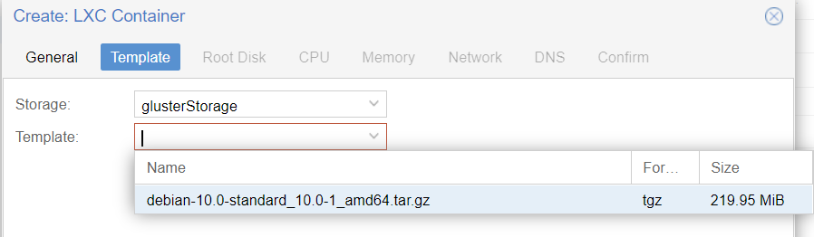

Configuring and using the Ceph storage
Working we glusterFS shows how a replicated shared filesystem work. You have also seen that you can’t use glusterFS for everything.
We are now going to use another shared filesytem called Ceph.
Ceph can be used to store not only files, but also objects and blocks. You have to read https://www.redhat.com/fr/topics/data-storage/file-block-object-storage for an overview of these three storage modes.
Ceph is primarily supported by Red Hat. It is quite common in datacenters thanks to its easy integration with OpenStack. But it happens to be well supported also by Proxmox.

You have to watch this ~37 minutes video that give a very good overview of ceph by the people that developed it from the beginning. This video may be a little bit old, but still really interesting. As for the context, Inktank was the company that initially developed Ceph, and it was bought by Red Hat.
https://www.youtube.com/watch?v=7I9uxoEhUdY
After watching this video, answer the following questions. Don’t try to be exhaustive. Instead try to be concise and focus on the essential.

What is the business model of ceph ? Can I use it for free ?

What is the design philosophy of Ceph regarding the hardware you can install it over ?

What is the role of an OSD ? How many OSD can you have in a ceph cluster ?

What is the role the monitor nodes ? How many monitors do you need in a ceph cluster ?

A Ceph client want to access to some data. How does it know which OSDs contain those data ?
What does it mean when the speaker say “crush has no lookup” and why is it important ?

What is “thin provizionning” What benefits does it bring ?

It would be possible to create a Ceph cluster independently from Proxmox. Data stored on this cluster would still be available to hypervisors or directly to users.
However, and especially in the context of small deployments (a few hypervisors), it is possible to install the Ceph servers directly on the Proxmox hypervisors. This however means those hypervisors possess multiple storage devices (disk, ssd) that can be dedicated to Ceph.
In the case of Ceph, it is not recommended to use underlying RAID systems. Ceph will use its own algorithm to handle redundancy and data recovery. Using another layer providing this type of functionality can significantly degrade the performances will not providing additional benefits in data integrity.
In this lab session, we are going to use our three hypervisors as Ceph storage servers. Proxmox allow the managing of Ceph server through its web GUI, but everything could be done by command line (as on a dedicated Ceph server).
Hardware configuration
We have three operational proxmox nodes (proxmox1, proxmox2 and proxmox3).
We will first add 2 hard drives dedicated to ceph storage to each proxmox node.
- Type: virtio
- size:10GiB
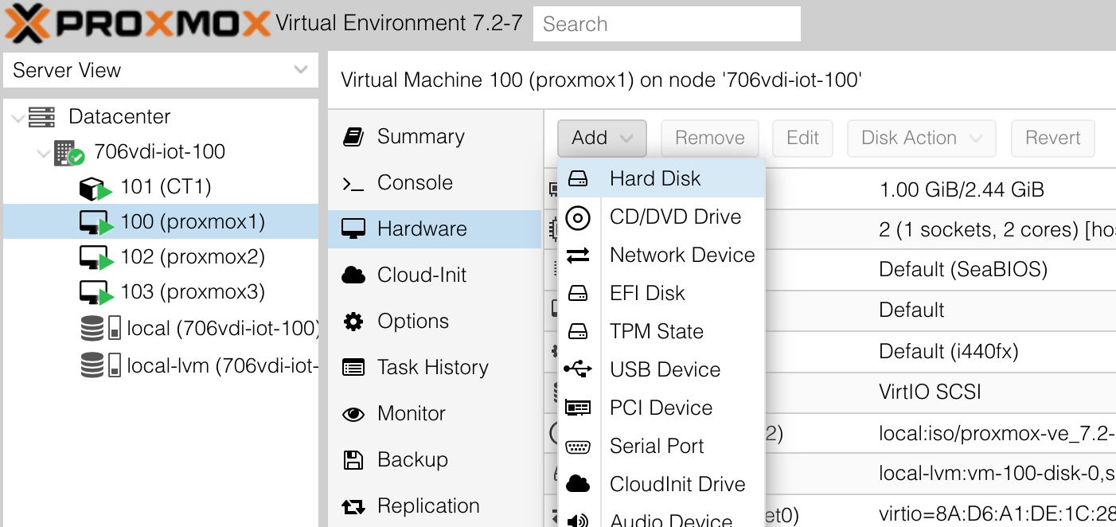

You should see 2 new 10GiB disk per proxmox virtual server:
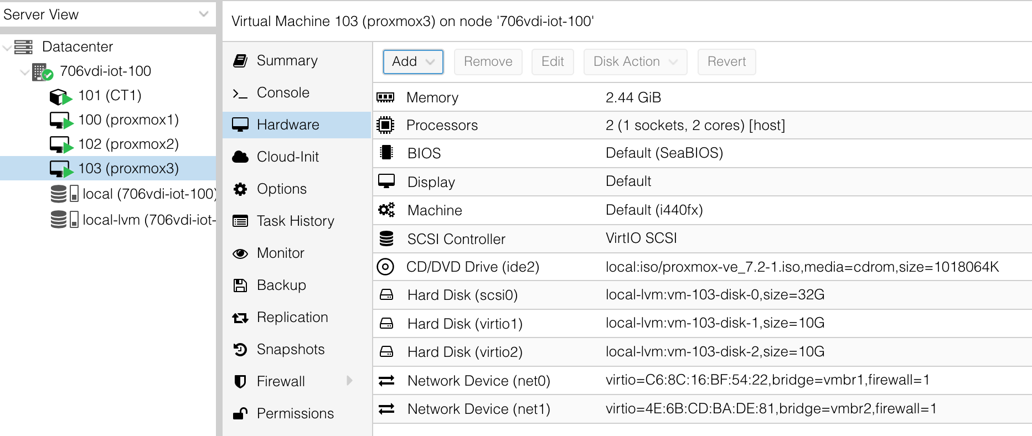
The Ceph packages are not installed in Proxmox by default, but can be added very easily. You now have to connect to your own proxmox cluster (it does not matter if you connect to proxmox1, proxmox2 or proxmox3 … from one of them, you can also control the others).
Choose one of your servers and start installing.
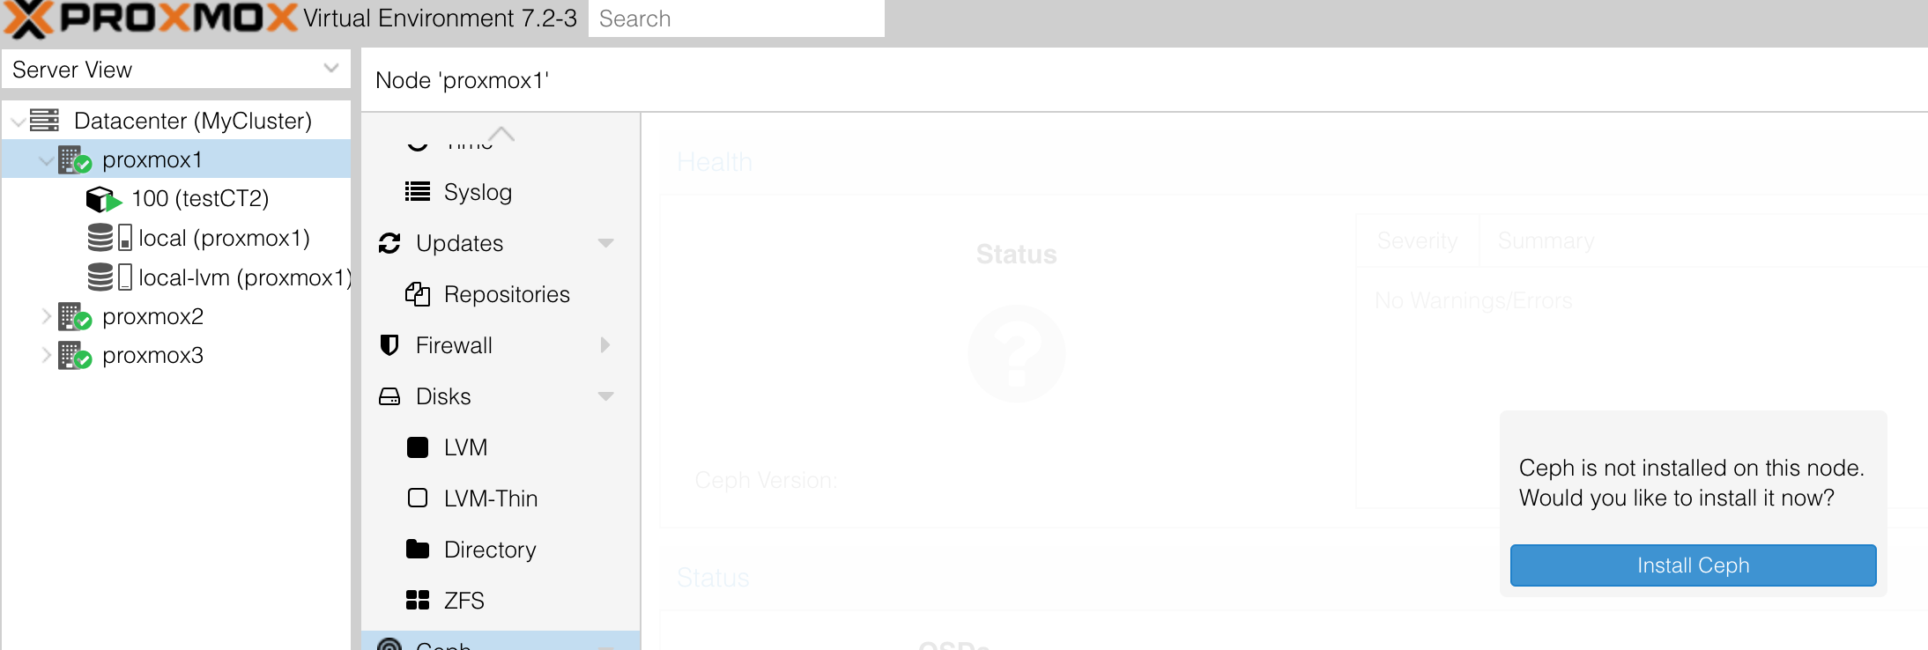

It will have to install some packages, you have to allow it.
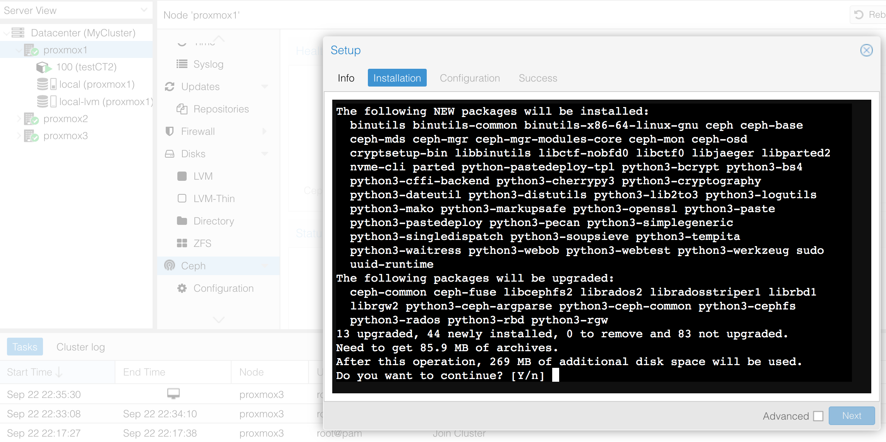
Once finished installing, you will have to configure ceph. Use the two sub-networks we created earlier. One public and one for cluster and data management.
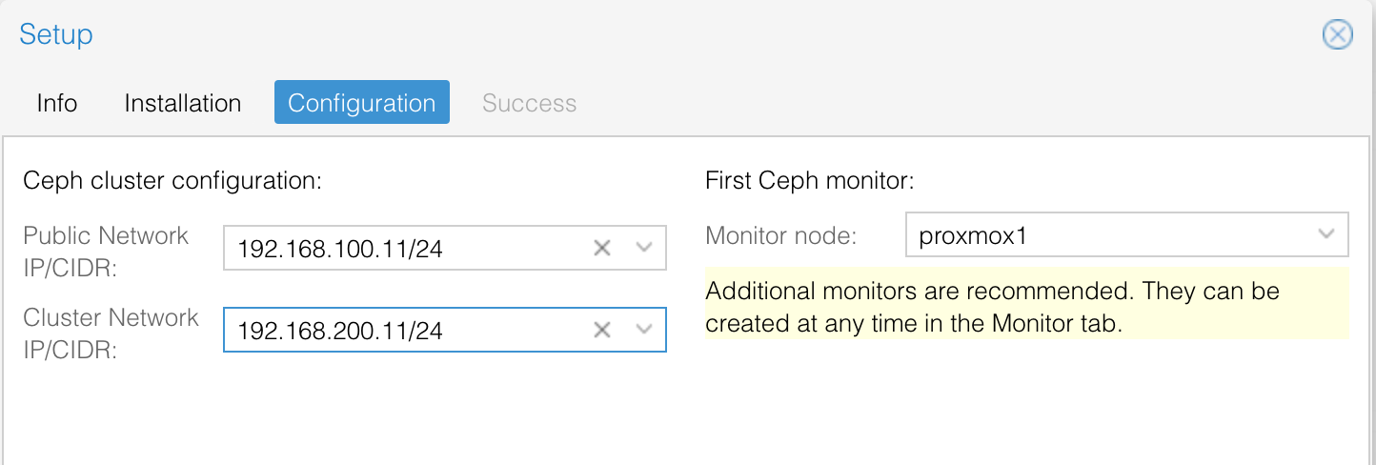
What does it means to have “number of replicas = 3” and “minimum replicas = 2” ?

Installation of ceph on the first node should be complete. But you
- installed the software on only one server,
- created (automatically) one monitor
- did not create any OSD at all.
You have first to install ceph on the other nodes of your proxmox cluster. Don’t forget to click “next” when installation will be finished.
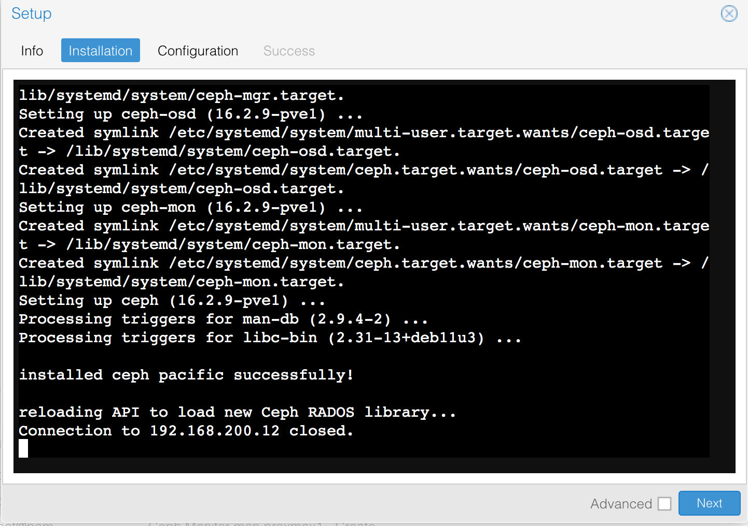

You don’t have to configure Ceph again, as it had been done with the first node. You should get a “Configuration already initialized” message.

Creating complementary monitors
Ceph requires at least one monitor running in the cluster. In fact, you should have more, and ideally an odd number of them.
We are going to add two more monitors, for a total of three (one per server).
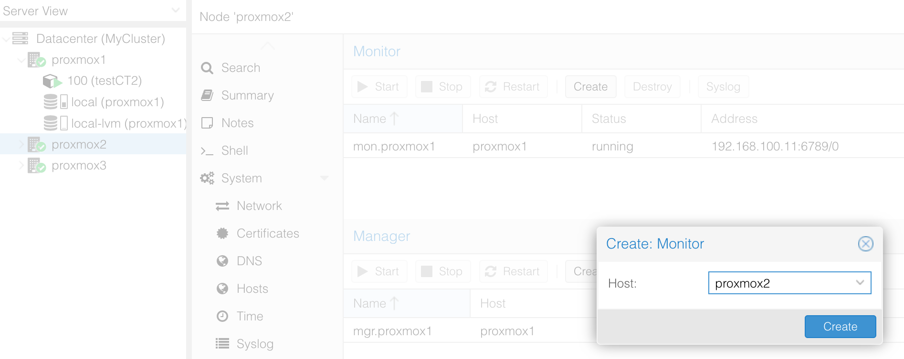

Creating complementary managers
The Manager daemon runs alongside the monitors. It provides an interface to monitor the Ceph cluster.
One manager was created on the first server, we need to add more, to provide redundancy.
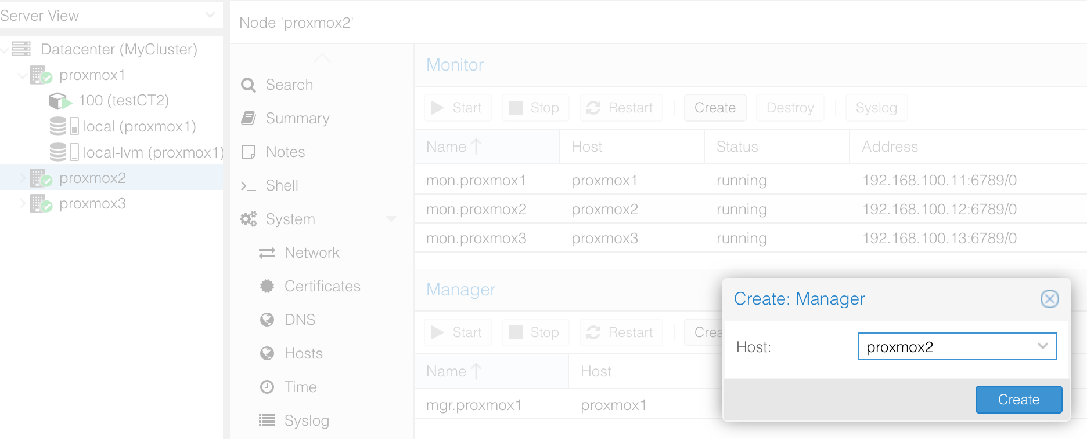
After adding the new monitors and managers, your setup should look like this:
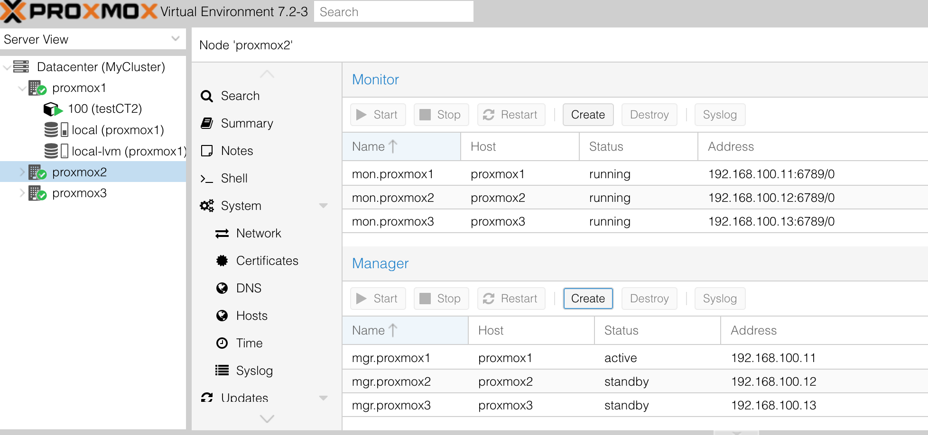

Note that all monitors are running, but only one manager is active while the ttwo others are on standby.

Adding OSDs
One the monitor are up and running, we can start to add OSDs. We will have two OSDs per server, but in a real deployment we could have many more
You should keep in mind that you should not:
- Have some OSDs too big compaired to the total size of the cluster. An OSD should normally not be more than 10 to 15% of the total space. Having a bigger OSD means that it will contain a large part of the data and thus will get much more I/O than others OSDs. It would become a bottleneck in your cluster.
- Have a too low number of servers. I one of them fails, all your data should exist somewhere else.

OSD is an acronym, what does it stand for ?

You need to create 6 OSD – one per disk you previously added to your servers.
You should get something like this:
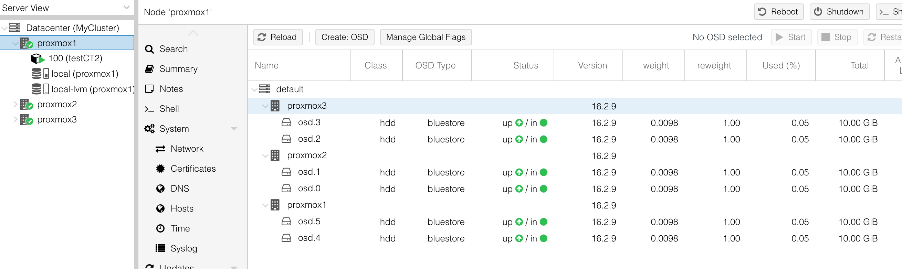

Adding a Ceph pool
While OSDs form the lowest level in the storage architecture, they cannot be used directly. They have to be organized in pools.
You can configure a pool to your needs, for example you can specify the redundancy level that you want.
You can create one or more pools over your cluster (using the OSDs of this cluster). The rules can differ from one pool to another.
In a given pool, you will find given number of Placement Groups (Pgs). Pgs are the basic units that are going to be replicated and sometime moved over the OSDs.
Too many PGs and you put a burden on the code having to compute their location in the cluster. Not enough and you will make it hard for Ceph to evenly distribute data over the pool.
Ceph team provides a calculator to guide the administrators configuring their pools:
https://ceph.com/pgcalc/
Considering that we will use only one pool (“all-in-one” use case provided in the calculator), how many PGs should we have in our pool ?

Do not check the “Add the new pool to the cluster storage” box.
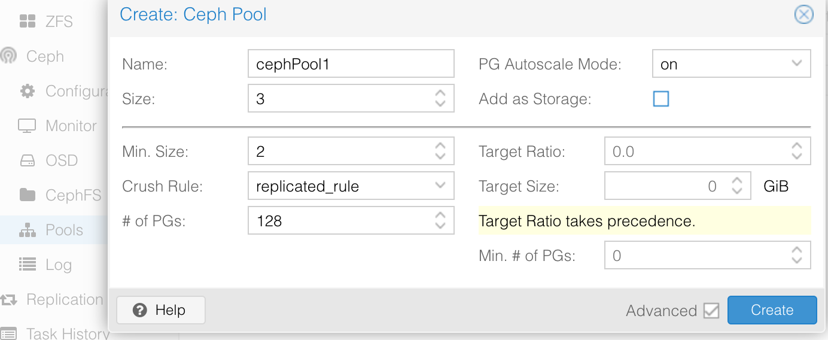

Using the ceph pool through RBD
Now that we have a pool, we can access it in different ways.
For now, we want to use it to store Virtual Machines and containers. This will bring the huge benefit to run Virtual Machines and containers in any hypervisor (proxmox1, proxmox2 or proxmox3) without having to worry about the location of the data.
For this usage, it is best to use Rados Block Device (RBD) as the way to access to the Ceph cluster.
The KVM software and proxmox know natively how to use RDB, so Ceph and Proxmox integrate very well. Others major hypervisors also know how to use RDB.
To use this new storage space, we have to go to the “storage” section of the proxmox cluster, and choose “add”. It will then becomes visible for all nodes in the cluster.
Choose a name (for example “sharedRBD”) and don’t forget what type of content you want to allow in this storage. We want both “disk images” and “containers”.
Note that the pool and the monitors of your Ceph cluster should have been detected automatically.
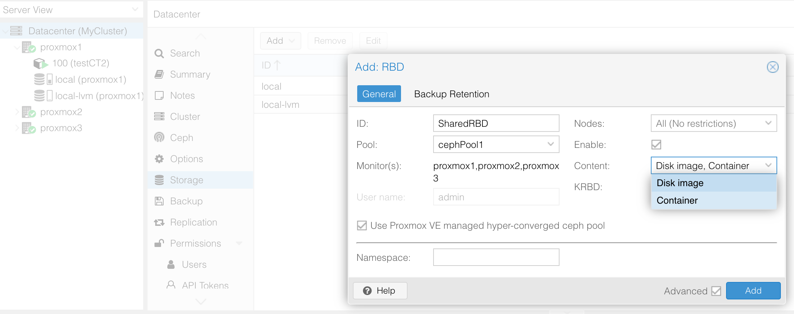
By default, the new storage will be accessible to all nodes of your Proxmox Cluster.
If required, you could limit the visibility to some nodes only. For now, just let all nodes access the RBD storage.
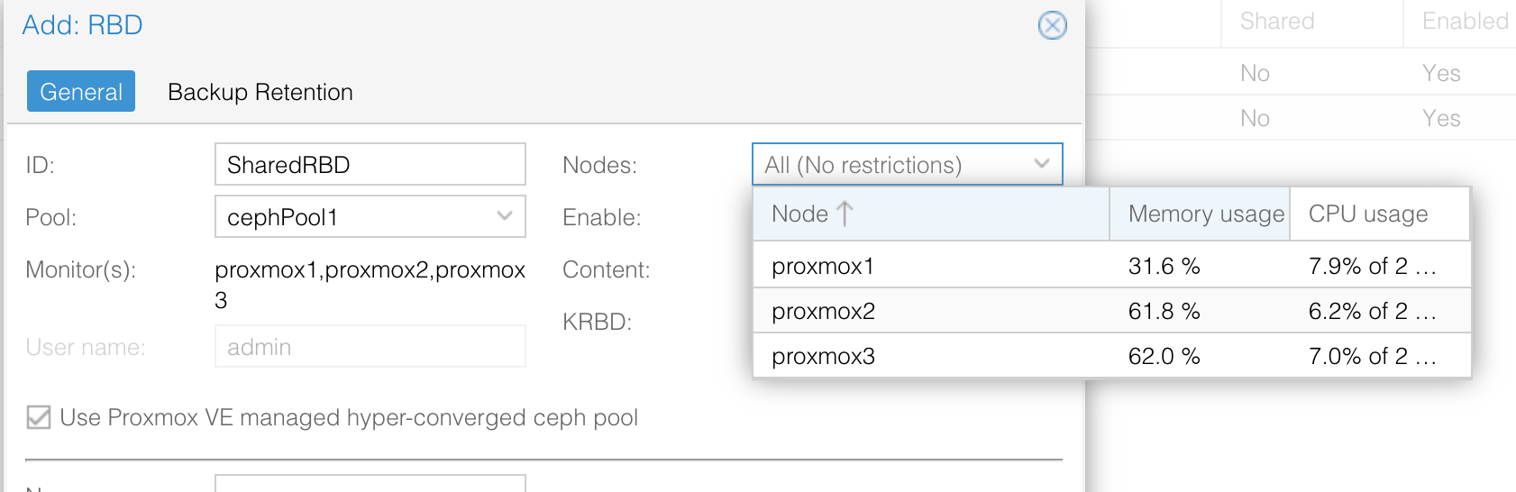
Once the storage has been created, you should see it appear on all nodes of your Proxmox cluster:
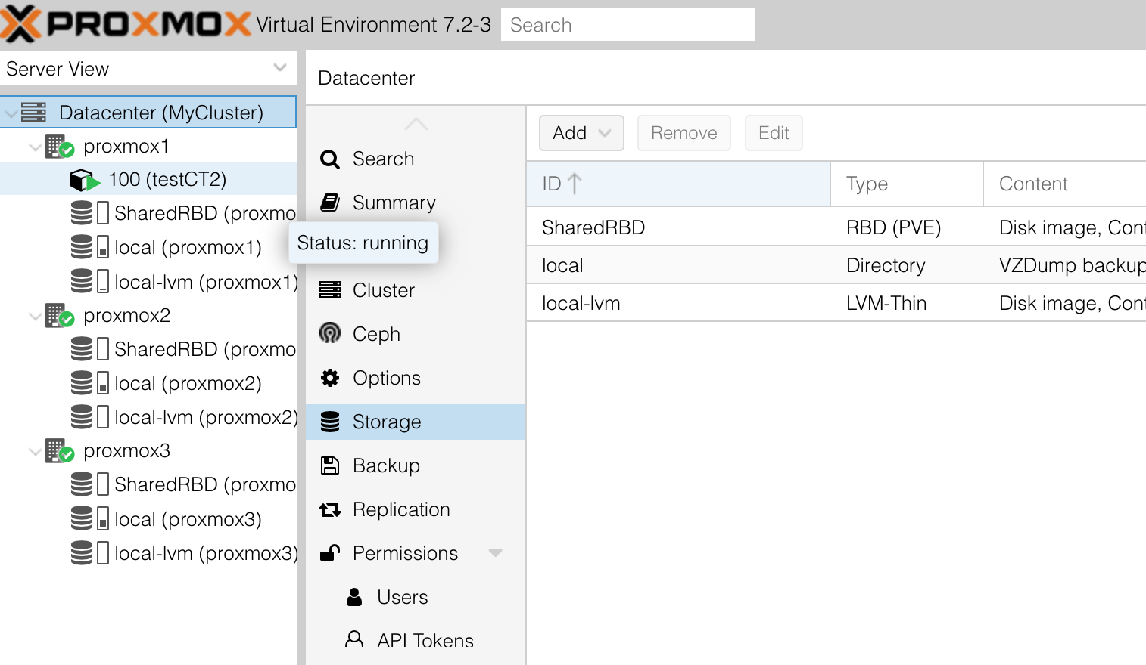

We could now use this storage when creating VM and containers. All the data will be replicated over your 6 OSDs.
In case of failure, this system will continue to work transparently. Moreover, the Ceph OSDs will talk to each others in the background and make more copies of the data that were on the lost storage. If necessary, the will redistribute the existing data to reach a new evenly distribution of the I/O load.

Using the ceph pool through CephFS
You should have noticed that only some types of content can be store with RBD (basically large blocks of data that correspond to hard drive partitions, so Virtual machines disks and containers).
If we want to store backups or container images (zip files), or ISO installation images, we need a filesystem.
CephFS is design for this use case.
CephFS rely on the underlying Ceph architecture (OSDs, monitors and pools). But to store individual files, you need an additional component that will manage the mapping between POSIX file paths (and their meta data such as file ownership, permissions, dates, …) and the low level objects managed by RADOS.
This new component is called a metadata server. As for the monitors and the managers from before, you need at least one, but preferably more …
So we will start by adding a few metadata servers to our Ceph pool.
You have to select one of your proxmox nodes and go to its “Ceph” section. Here, select the “CephFS” subsection.
You will see that for now you have no metadata server. But you can add some !
Add one per proxmox node (proxmox1, proxmox2, proxmox3)
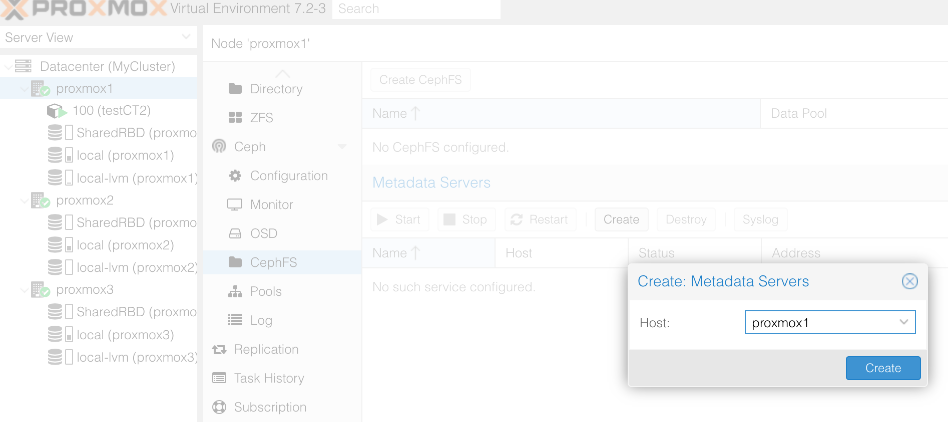

At first, your metadata servers should be on standby, as they do not share a CephFS yet:
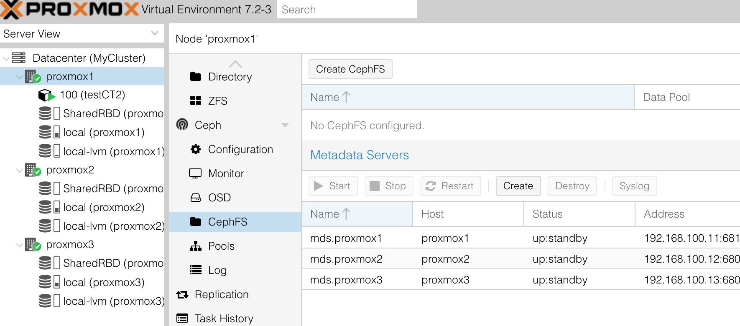
So you need to create a new CephFS (use the “create CephFS” button). Uncheck the “add as storage” box.
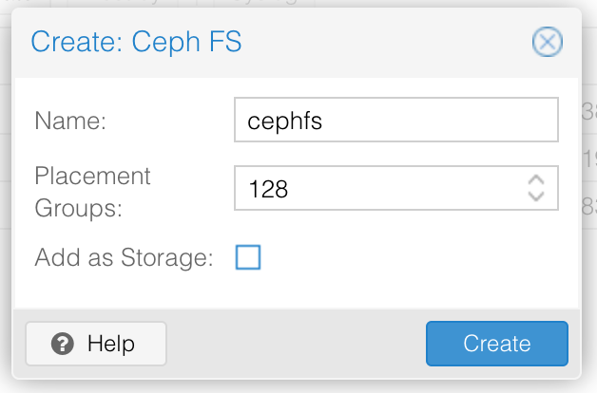

Note that as for RBD, a pool is required to dispatch data over the underlying OSDs. In this case, multiple poosl are automatically created (one to store the files and one to store the metadata – file permissions and other properties).
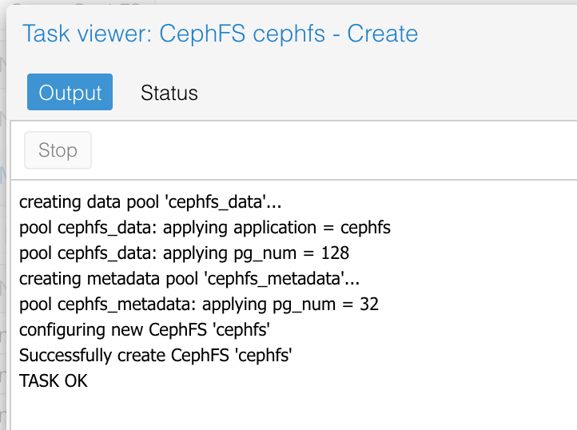

You may now add this CephFS as a new storage to your Proxmox Cluster. Don’t forget to select the types of content you want to allow.
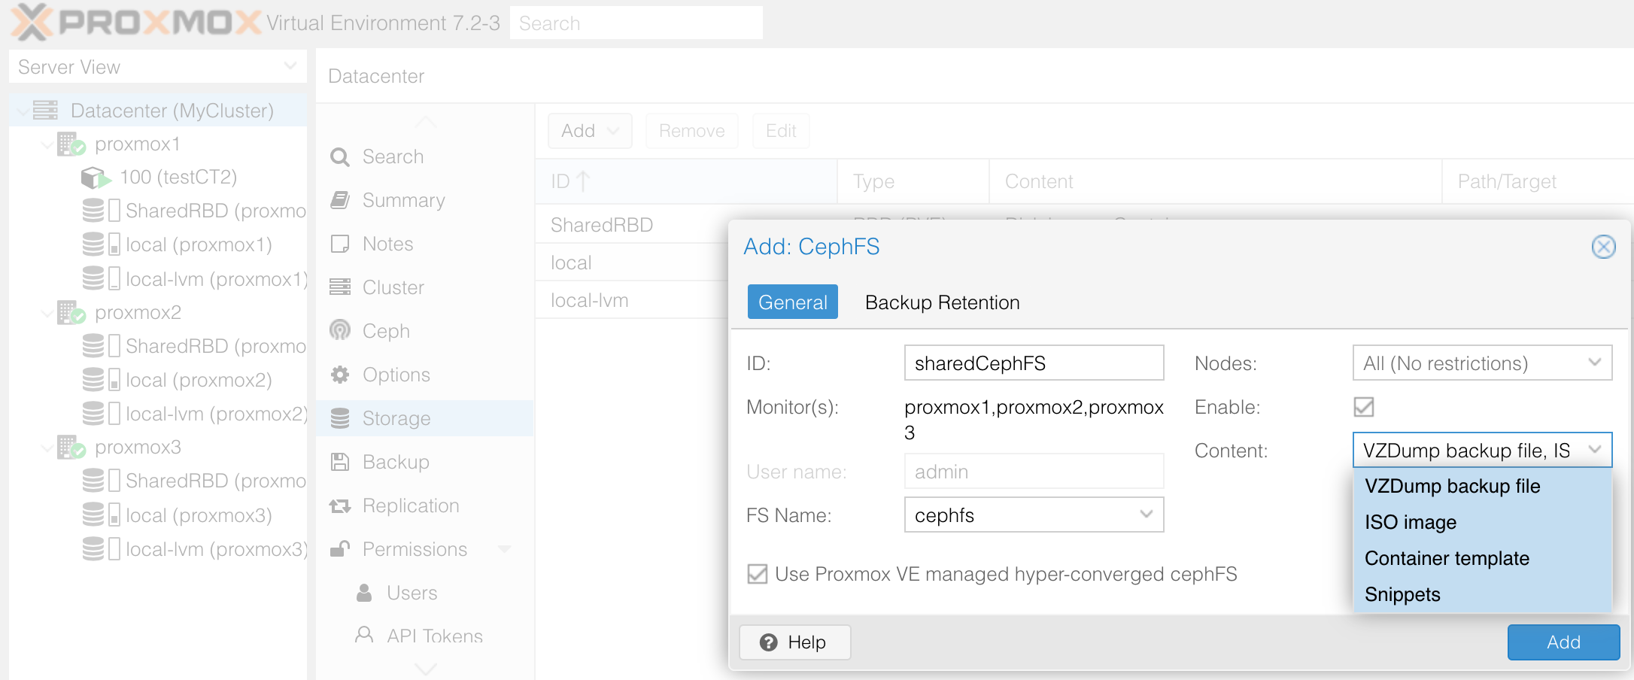
Congratulations, you now have a redundant storage for all your virtualization needs !

Test High Availability
We now have all the components required for High Availability (HA):
- A Proxmox cluster providing redundancy of hypervisors
- A Ceph (also redundant) shared storage, to store the VMs and containers.
We will:
- Download a template and put it on the shared CephFS storage. That way, the same template can be used to create new containers on any node of the cluster.
- Create a container using this template and stored on the sharedRBD Ceph storage. That way, it could be accessed and runned by any node of the cluster.
- Install a simple webserver and website inside this container. Also test it.
- Configure High Availibility so that the web server container should always run. Specify preferred location (on which node to run it).
- Kill the node running the server, and observe the container migrate and Ceph reorganizing it’s placement groups.
- Restart the missing server, and observe everything returning to normal.

Lest begin by downloading a template. We will use a very lighweight one, using the “Alpine” Distribution. It’s based on busybox … it’s really small, and contain pretty much nothing by default.
Store the template on the CephFS shared filesystem.

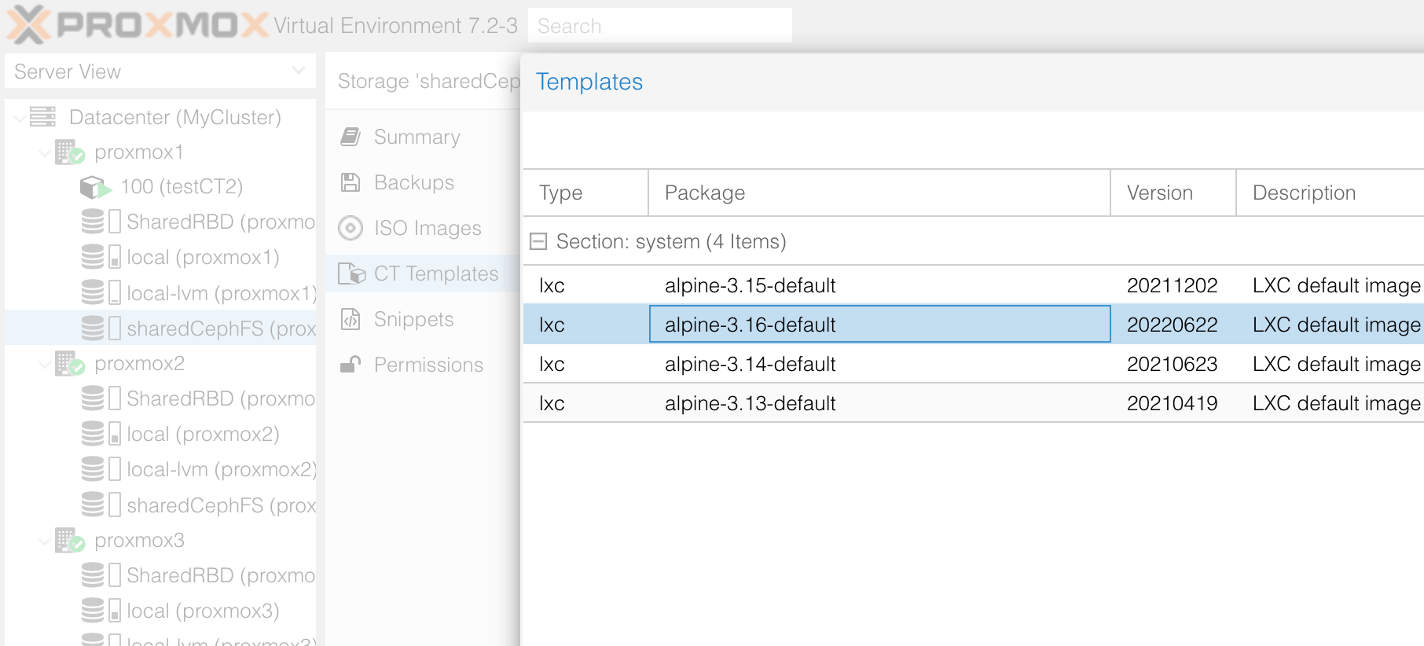
Then create a new container on your proxmox1 based on this template
- General
  - name: testWebServer
- Template
  - the one you just downloaded, from your CephFS
- Root disk
  - on sharedRBD, 4GiB
- CPU
  - 1 core
- Memory
  - 128MiB
- Network
  - bridge vmbr0 – address 192.268.200.xxx/24 – gateway 192.168.200.10
We then start this container and log into it. As it is not based on debian, the commands to install new software are a little different from before.
To update the package list:
testWebServer:~# apk update
Note: You may need to configure the proxy with setup-proxy
To install a small webserver:
testWebServer:~# apk add lighttpd
To install nano (vi is pre-installed if you prefer to skip this step):
testWebServer:~# apk add nano
If you are using nano, you will have a problem with the virtual terminal. It’s a problem with the Alpine container for Proxmox, that incorrectly set the TERM environment variable. Set it to a usable value:
testWebServer:~# export TERM=linux

You need to add a basic web file for you web server to publish
testWebServer:~# nano /var/www/localhost/htdocs/index.html
And put this sort of content:
<!DOCTYPE html>
<html>
<head>
<title>My resilient web server</title>
</head>
<body>
It works !
</body>
</html>

Now you can add the webserver to the startup procedure:
testWebServer:~# rc-update add lighttpd default
And start it immediately:
testWebServer:~# rc-service lighttpd restart

You can test your new web server by opening it on a web browser.
You will need to add a port redirection on 706vdi-iot-xxx for that.

Configure High Availability
Select your datacenter, and go to the “HA” section.
On the upper part you should see the list of the nodes. You should also see that a quorum was attained and a master elected. It’s role is to prevent inconsistency in running the virtual machines.
On the lower part, you can add resources to be managed by the High Availability service.

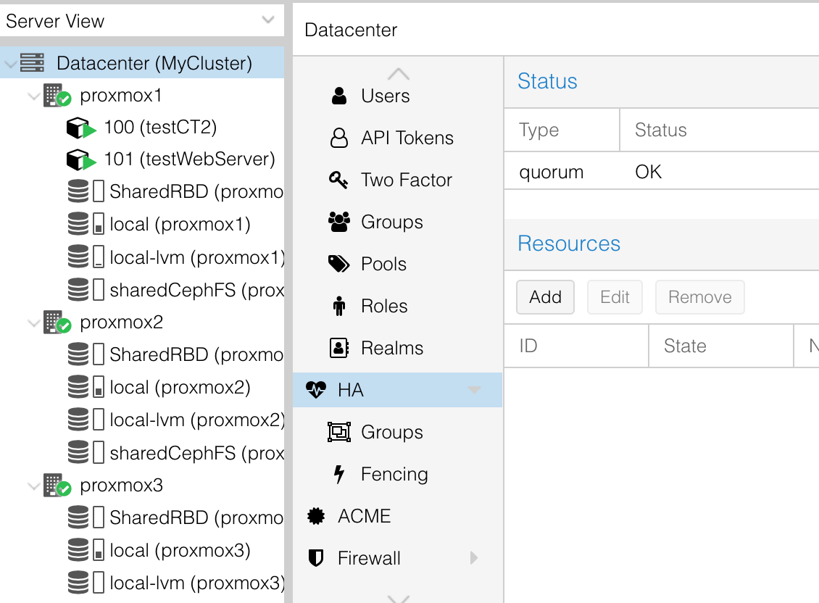

When adding a resource, you have to select your web server’s container. Groups are used to restrict on which hypervisors a VM can run on. For now, we don’t have a group. This will mean that we ask the HA manager to restart the container in case of unavailability, but restart it anywhere – no particular preference.
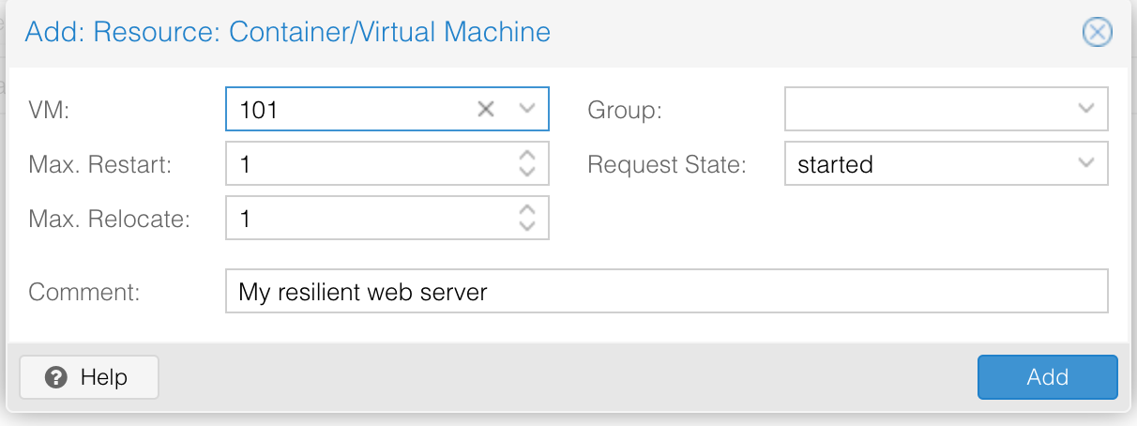
You can validate.
However, this behavior is usually not desired. Without specifying a preferred location, it could lead to many VMs running on the same node while some others are kept idle.
To prevent this, we will create a group.
We add a new group, called “webServerGroup”.
We can select all proxmox nodes (it means the service could run on any of them). But we specify priorities. The higher the number, the higher the pirority. Set it as in the example. This means that the service should run on proxmox2. But if unavailable, it should run on proxmox3, and in the worst case on proxmox1.

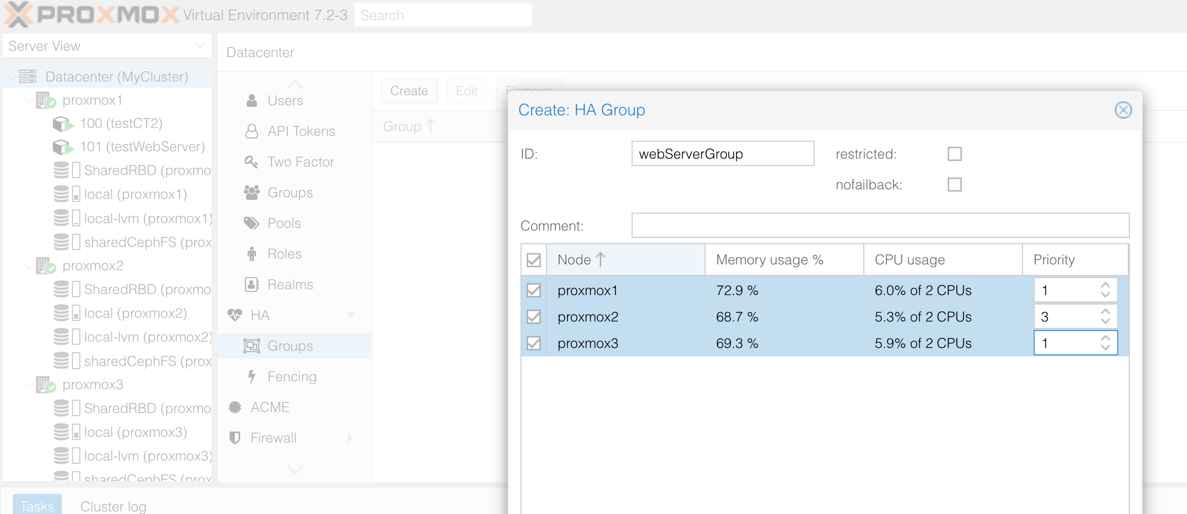
Then go back to the HA ressource and add the group to your CT:
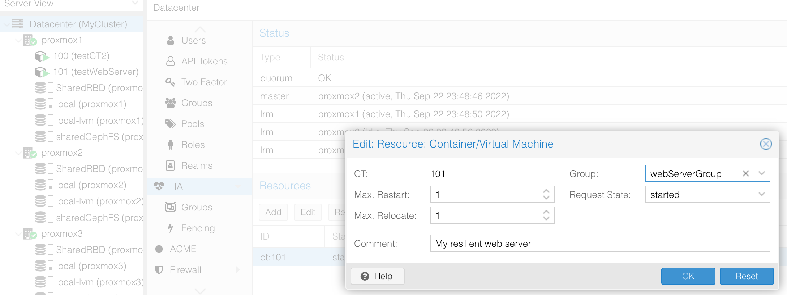
Your done with the installation and configuration, so let’s observe !
After a few seconds, you should see the web server move to proxmox2. This is normal considering the priorities we just set.
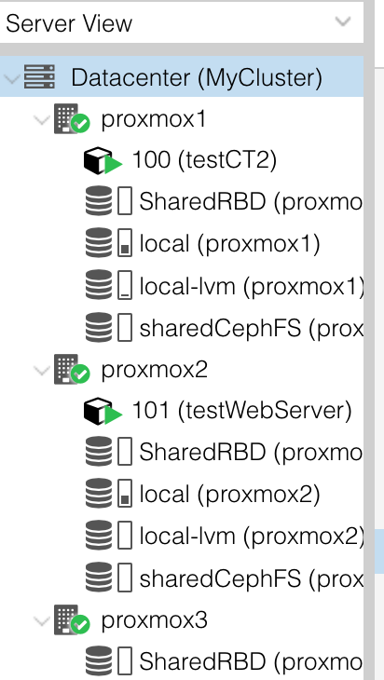

Also, you can also go observe the state of the Ceph cluster. Everithing should be green, with all 6 OSDs In and Up.
The state og Placement Groups (PG) should be “active+clean”.
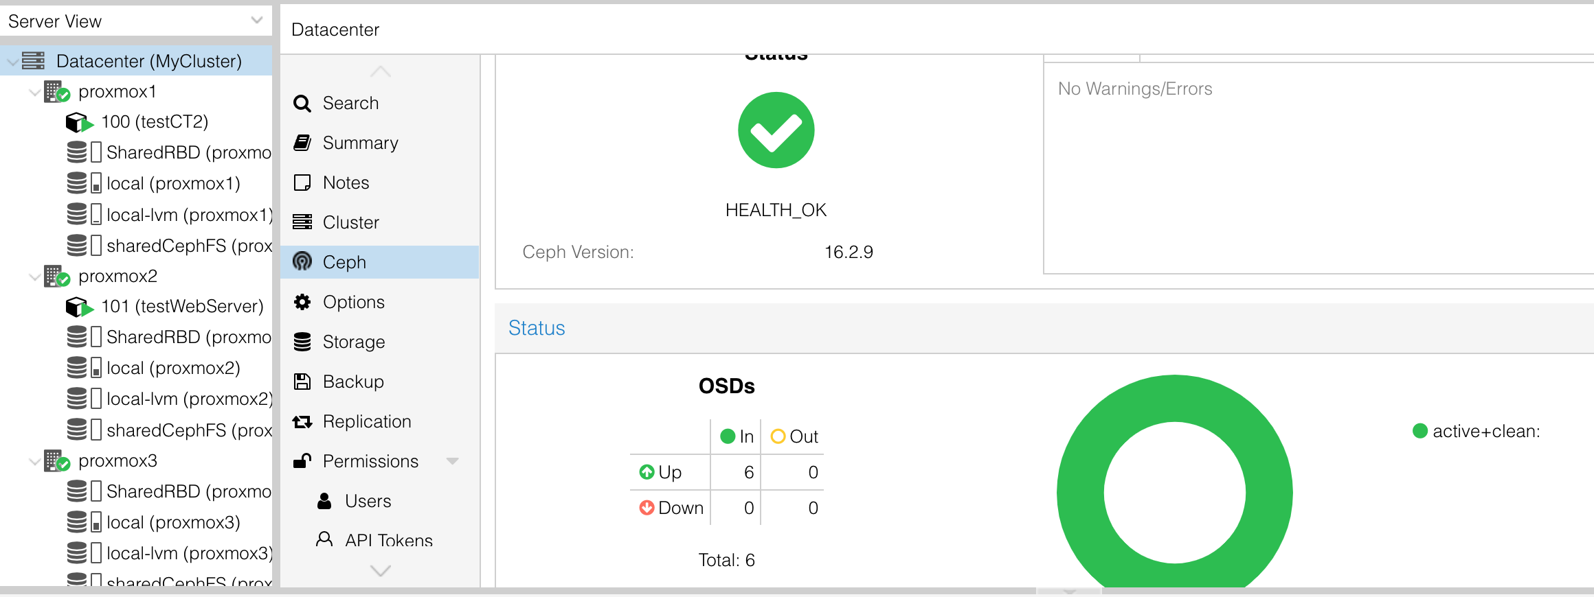
We are now going to kill proxmox2 (the node were the webserver run). To better observe what is happening, you should make sure your are not connected to the web GUI of proxmox2 (use proxmox1 or proxmox3).
We use the “Stop” function in the menu of the 706vdi-iot-xxx. This simulates a crash.
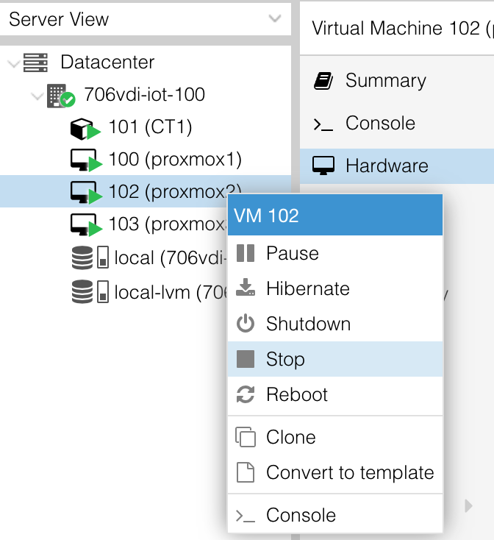

The cluster will not react immediately … it wants to be sure the node is dead before starting to move things.
But after around 1 minute, you should see the state of the HA resource change to “fence”:
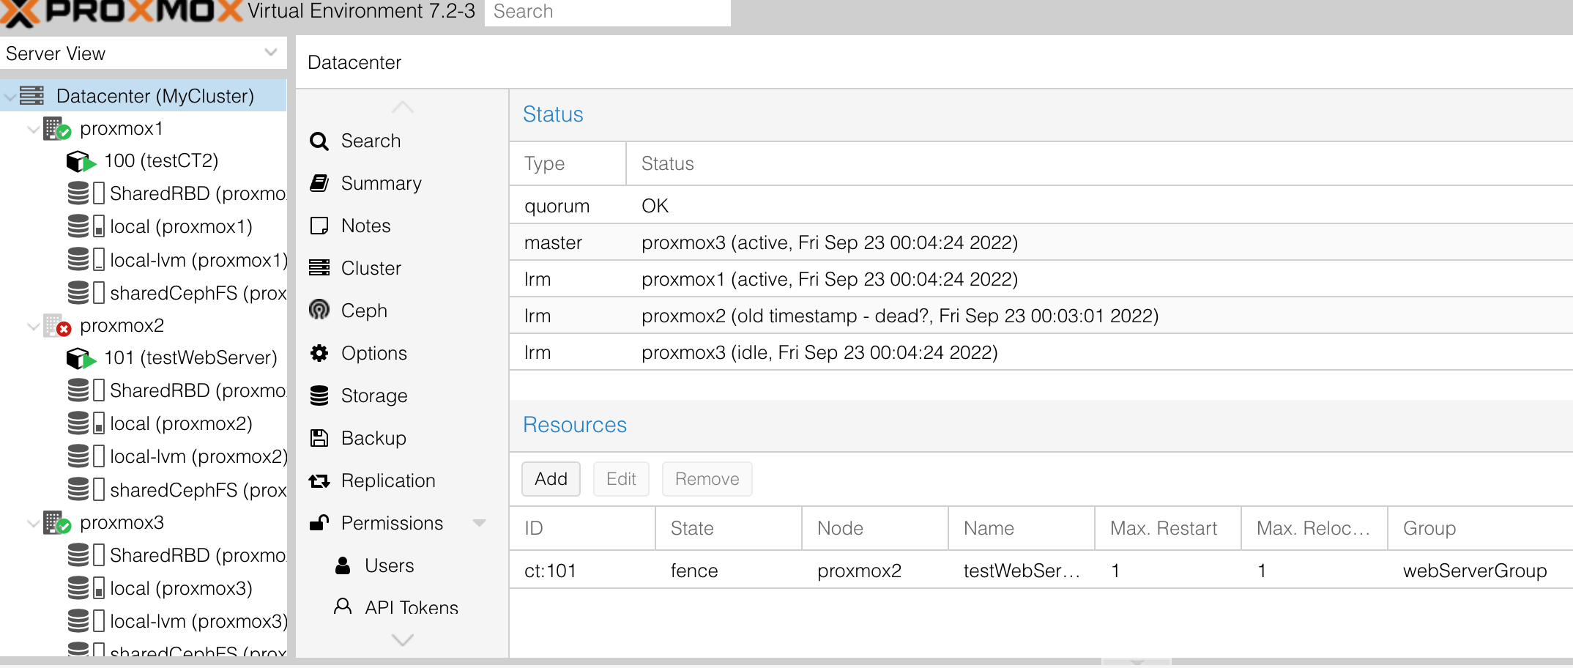
What does “fence” means in this context ?

Also, after some time, the state of Ceph will change, to reflect that some OSDs are down:
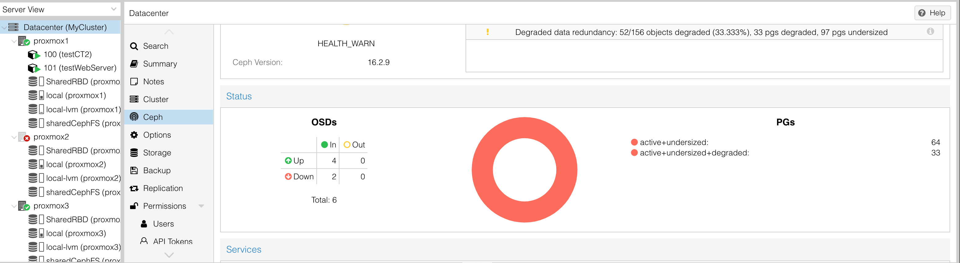
After a minute or two, you will see the webserver restarting on proxmox3 (next in line in its priority list), and the service becomes available again. You can test with your browser as before. Note that the URL and thus the IP address of the server did not change during the whole process, even if the virtual machine migrated from one host to another !
As the OSDs from proxmox2 are considered “down”, we can observe that Ceph work in a degraded manner, but still work. Ceph is also still considering the whole set of 6 OSDs (~60GiB total)
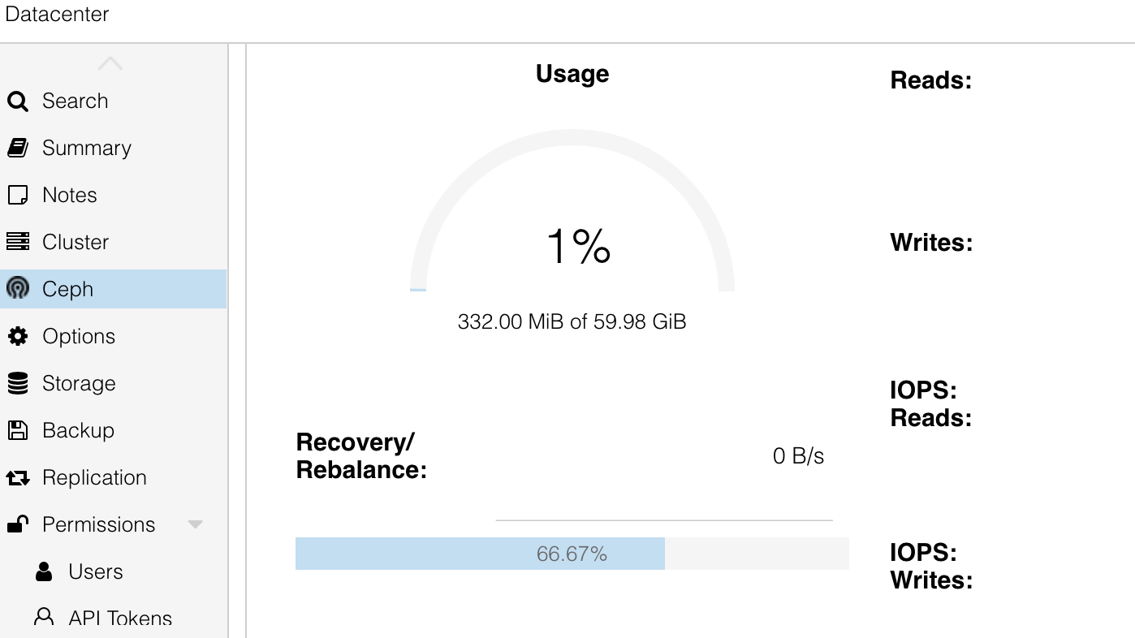
If you ait long enough (by default 10 minutes), Ceph will consider that proxmox2 is completely “out”, instead of just “down”. And calculate total storage space accordingly:
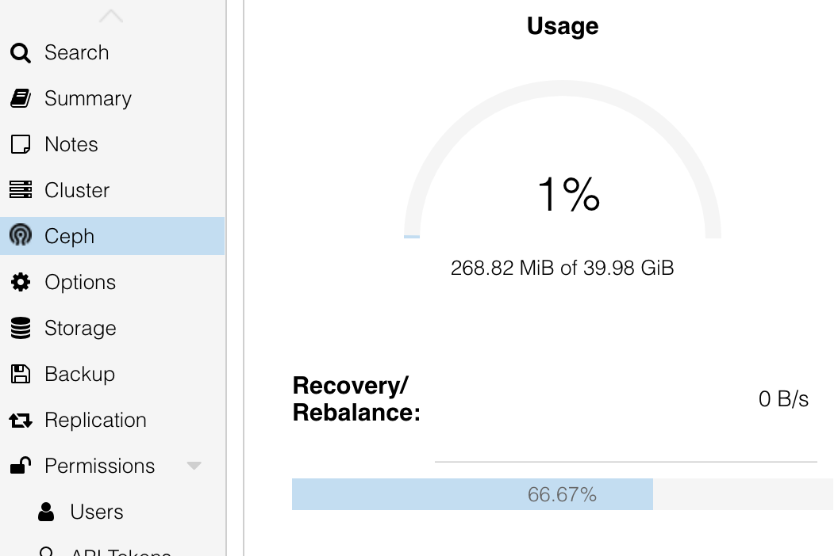

Last thing to do is to plug proxmox2 back.
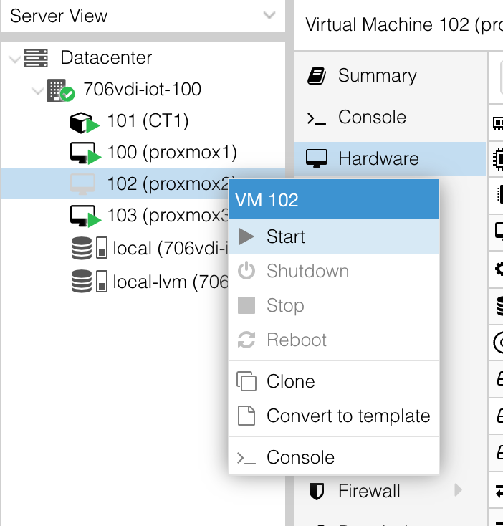

It will take some time (if you look at proxmox2 console, you will see the services restarting over the course of a few minutes), and in the GUI, you will be able to observe Ceph reorganizing the Placement Groups.
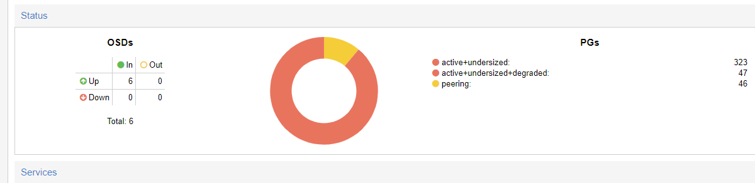
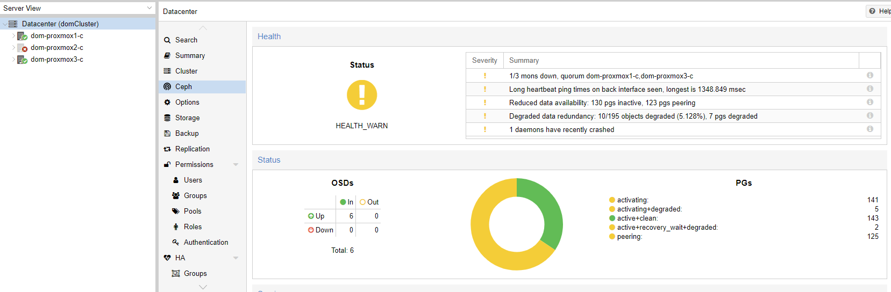
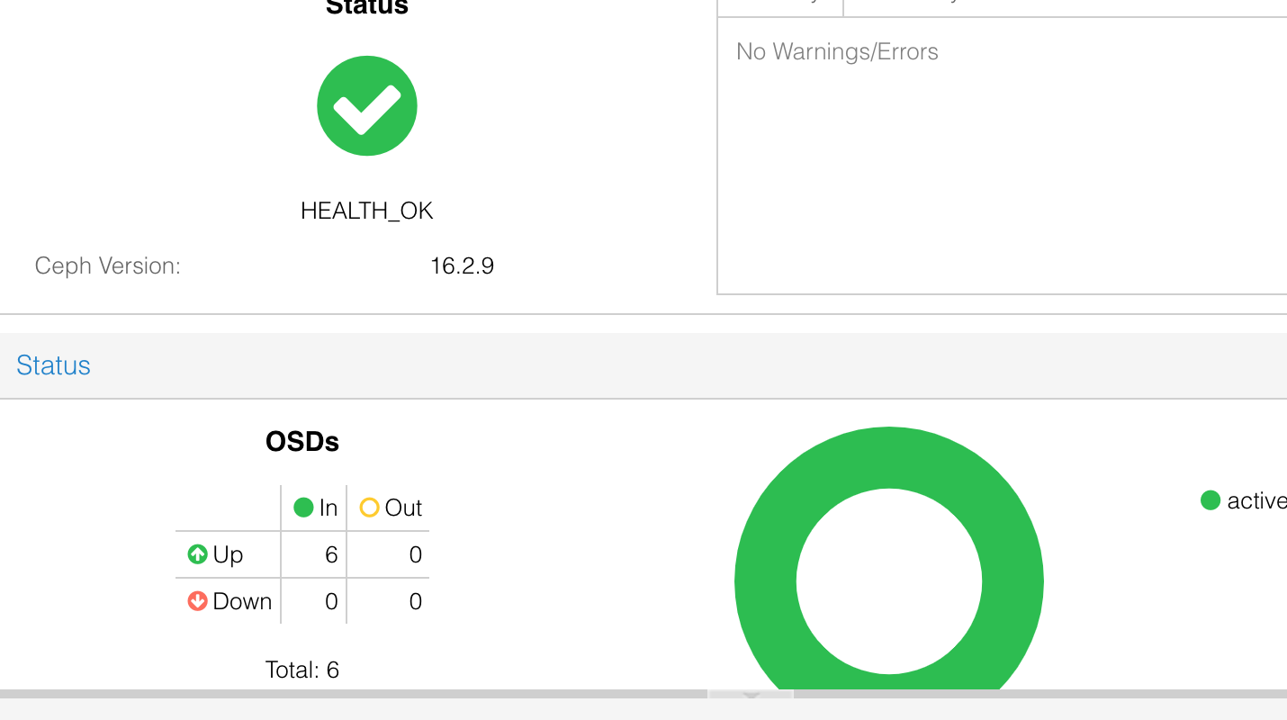

The webserver should finally come back to proxmox2 and resume normal operation !

